**Table 1:** Eelgrass meadows sampled for biodiversity in the summer of 2012 in Trevor Channel, Barkley Sound, B.C. (Figure 1). Sites were sampled at three times: early summer (E), mid-summer (M), late summer (L). Meadow biotic and abiotic properties were estimated, including shoot density (No. shoots/ 0.28 m2 plot), Leaf Area Index (LAI) per plot, estimated from shoot density and measured widths and longest length of seagrass blades (*1000 cm2), and epiphyte biomass (g dry wt / g eelgrass dry wt). Position is the approximate distance of the meadow from Alberni Inlet freshwater output (km).

|  |  |  |  |  |  |  |  |  |  |  |
| --- | --- | --- | --- | --- | --- | --- | --- | --- | --- | --- |
| Crow Cove (CC) |  | -, 14.6, - | -, 15.8, - |  |  | -, 0.08, - | 2.2 | 48.98485 | 125.00338 | July 25 |
| Boyson Islands (BI) |  | -, 17.1, - | -, 15.7, - |  |  | -, 0.67, - | 5 | 48.97030 | 125.02855 | June 20 |
| Crickitt Bay (CB) | 0.50 | 16.1, 17.6, 15.4 | 12.2, 15.9, 19.4 | 4, 7.25 | 1.9, 3.6 | 0.19, 0.14, 0.09 | 5.8 | 48.94095 | 125.01862 | May 26, July 5, Aug 11 |
| Numukamis Bay (NB) | 2.70 | 17.0, 16.3, 13.7 | 12.3, 15.8, 21.4 | 6.5, 9.5 | 1.6, 4.3 | 0.34, 0.36, 0.30 | 10 | 48.90652 | 125.01233 | May 24, July 10, August 9 |
| Robber’s Passage (RP) | 0.72 | 23.5, 22.0, 17.8 | 11.9, 15.2, 17.8 | 7.7, 8 | 2.2, 4.5 | 0.32, 0.18, 0.14 | 15.4 | 48.89413 | 125.11840 | May 22, July 3, August 7 |
| Ellis Island (EI) |  | -, 21.5, - | -, 15.4, - |  |  | -, 0.14, - | 19 | 48.86303 | 125.10570 | July 23 |
| Bald Eagle Cove (BE) |  | -, 23.5, - | -, 14.4, - |  |  | -, 0.18, - | 19.4 | 48.87487 | 125.15497 | June 15 |
| Wizard Islet (WI) | 0.26 | 21.6, 22.7, 18.6 | 11.8, 13.5, 17.0 | 8, 7.8 | 3.9, 4.6 | 0.34, 0.30, 0.31 | 20.6 | 48.85825 | 125.15867 | May 20, June 30, August 5 |
| Dodger Channel (DC) | 2.30 | 27.6, 24.9, 22.1 | 11.5, 13.0, 14.9 | 12.3, 12.7 | 8.0, 7.9 | 0.06, 0.28, 0.04 | 24.4 | 48.83372 | 125.19533 | May 28, June 27, August 3 |
| **Site name** | **Area (ha)** | **Salinity (ppt)**  **E, M, L** | **Temp.**  **(°C)**  **E, M, L** | **Shoot density**  **E, L** | **Leaf area index (LAI)**  **E, L** | **Epiphyte load (g)**  **E, M, L** | **Position (km)** | **Lat. (N)** | **Long. (W)** | **Dates sampled (2012)** |

**Table 2:** Coefficients from best models (mod) from linear regression analyses testing for variation in abiotic and biotic meadow properties (Appendix 1) with sampling date and position in the watershed (Table 1). Model coefficients and 95% confidence intervals for best models for meadow-scale characteristics. Res. = median residual values. Bold values indicate coefficients for which confidence intervals do not include 0.

|  |  |  |  |  |  |  |
| --- | --- | --- | --- | --- | --- | --- |
| **Response** | **mod** | **Intercept** | **Time** | **Position** | **Time*Pos.** | **Res.** |
| Temperature | A3 | **8.69**  [6.32,11.07] | **3.30**  [2.42, 4.18] | 0.069  [-0.073,0.21] | **-0.08**  [-0.13, -0.03] | 0.06 |
| Salinity | B2 | **16.29**  [13.61, 18.98] | **-1.22**  [-1.98,-0.45] | **0.44**  [0.33,0.56] |  | 0.28 |
| Shoot Density | C2 | 3.07  [-0.79, 6.93] | 0.45  [-0.42, 1.32] | **0.27**  [0.08, 0.47] |  | 0.09 |
| Leaf Area Index | D2 | -606.53 [-3673.36, 2460.31] | 478.94  [-208.57, 1166.45] | **240.73**  [88.42, 393.04] |  | 41.2 |
| Epiphyte load | E1 | **0.29**, [0.10, 0.48] | -0.02, [-0.09, 0.04] |  |  | -0.05 |
| Effective number of fish species | -- | 2.84  [-1.65, 7.33] | -0.01  [-0.28, 0.25] |  |  | 1.47 |

**Table 3:** Modeled effects of time (t) and position within the watershed (P) on plot-scale diversity estimates of invertebrate assemblages. Model comparisons for mixed effects models with meadow as a random effect. AICc, AIC weight (*w*) and δAIC values, and results of likelihood ratio tests (P-values) that compare the model in one row with model Basic 1 (first row). The best model has the lowest AICc value, and likelihood ratio tests facilitate interpretation of the significance of differences in similar AICc values.

|  |  |  |  |  |  |  |  |
| --- | --- | --- | --- | --- | --- | --- | --- |
| **Model** |  | **AICc** | ***w*** | **df** | **logLik** | δ AIC | **P** |
| ln(Abundance) (N) | | | | | | | |
| **A3** | **ln(N) = t + P + t*P** | **196.7** | **0.824** | **8** | **-90.054** | **0.00** | **--** |
| A1 | ln(N) = t | 200.7 | 0.115 | 6 | -94.154 | 3.93 | 0.01 |
| A2 | ln(N) = t + P | 202.0 | 0.060 | 7 | -93.740 | 5.23 | 0.001 |
| Rarefied richness (RR) | | | | | | | |
| **B2** | **RR = t + P** | **1467.1** | **0.569** | **7** | **-726.317** | **0** | **--** |
| B1 | RR = t | 1468.9 | 0.232 | 4 | -730.371 | 1.79 | 0.04 |
| B3 | RR = t + P + t*P | 1469.2 | 0.198 | 8 | -726.301 | 2.11 | 0.86 |
| Simpson’s Diversity (SI) | | | | | | | |
| **C2** | **SI = t + P + t*P** | **-154.2** | **0.687** | **8** | **85.423** | **0** | **--** |
| C1 | SI = t | -151.3 | 0.160 | 6 | 81.832 | 2.92 | 0.03 |
| C3 | SI = t + P | -151.2 | 0.153 | 7 | 82.849 | 3.01 | 0.02 |

**Table 4:** Model coefficients for best model or best model set (Table 3) for variation in plot-scale epifauna abundance and diversity. Results from models that only included the five main sites were nearly identical, and therefore models that include data from all sites are shown here. Random effects not estimated for rarefied species richness because the models were averaged.

|  |  |  |  |  |  |  |  |
| --- | --- | --- | --- | --- | --- | --- | --- |
| **Response** | **mod** | **Intercept** | **Time** | **Position** | **Time*Pos.** | **Random effect:**  **Meadow ID** | |
|  |  |  |  |  |  | **Intercept (SD)** | **Time (SD)** |
| ln(Abundance) | A3 | **1.52**  [1.10, 1.83] | 0.03  [-0.06, 0.11] | -0.01  [-0.04, 0.01] | **0.02**  [0.01, 0.02] | 0.32 | NA |
| Rarefied Species Richness | B2, B3 | **6.64**  [3.98, 9.30] | **1.42**  [0.34, 2.50] | 0.04  [-0.15, 0.24] | 0.00  [-0.12, 0.13] | -- | -- |
| Simpson Index | C3 | **0.41**  [0.19, 0.63] | **0.08**  [0.03, 0.12] | 0.01  [-0.01, 0.02] | 0.00  [-0.01, -0.00] | 0.02 | NA |

**Table 5:** Modeled effects of time (t) and position within the watershed (P) on plot-scale diversity estimates of the subset of grazers in invertebrate assemblages. Model comparisons for mixed effects models with meadow as a random effect. AICc, AIC weight (*w*) and δAIC values, and results of likelihood ratio tests (P-values) that compare the model in one row with model Basic 1 (first row). The best model has the lowest AICc value, and likelihood ratio tests facilitate interpretation of the significance of differences in similar AICc values.

|  |  |  |  |  |  |  |  |
| --- | --- | --- | --- | --- | --- | --- | --- |
| **Model** |  | **AICc** | ***w*** | **df** | **logLik** | δ AIC | **P** |
| ln(Abundance) (N) | | | | | | | |
| **A1** | **ln(N) = t** | **531.5** | **0.63** | **6** | **-259.583** | **0.00** | **--** |
| A2 | ln(N) = t + P | 533.2 | 0.26 | 7 | -259.405 | 1.74 | 0.54 |
| A3 | ln(N) = t + P + t*P | 535.0 | 0.10 | 8 | -259.277 | 3.60 | 0.76 |
| Rarefied richness (RR) | | | | | | | |
| **B1** | **RR = t** | **1617.5** | **0.658** | **6** | **-802.594** | **0.00** | **--** |
| B2 | RR = t + P | 1619.6 | 0.231 | 7 | -802.593 | 2.10 | 0.97 |
| B3 | RR = t + P + t*P | 1621.0 | 0.111 | 8 | -802.272 | 3.56 | 0.72 |
| Simpson’s Diversity (SI) | | | | | | | |
| **C1** | **SI = t** | **-101.6** | **0.669** | **6** | **56.935** | **0** | **--** |
| C2 | SI = t + P | -99.5 | 0.237 | 7 | 56.945 | 2.08 | 0.89 |
| C3 | SI = t + P + t*P | -97.7 | 0.094 | 8 | 57.079 | 3.92 | 0.87 |

**Table 6:** Model coefficients for best model or best model set (Table 5) for variation in plot-scale abundance and diversity of the subset of invertebrate grazers. Results from models that only included the five main sites were nearly identical, and therefore models that include data from all sites are shown here. Random effects not estimated because the models were averaged.

|  |  |  |  |  |  |  |  |
| --- | --- | --- | --- | --- | --- | --- | --- |
| **Response** | **mod** | **Intercept** | **Time** | **Position** | **Time*Pos.** | **Random effect:**  **Meadow ID** | |
|  |  |  |  |  |  | **Intercept (SD)** | **Time (SD)** |
| ln(Abundance) | A1-3 | **1.62**  [0.78, 2.47] | 0.08  [-0.25, 0.42] | 0.00 [-0.07, 0.05] | 0.00  [-0.05, 0.03] | -- | -- |
| Rarefied Species Richness | B1-3 | **6.00**  [4.48, 7.51] | 0.51  [-0.29, 1.32] | 0.00  [-0.12, 0.14] | 0.00  [-0.12, 0.05] | -- | -- |
| Simpson Index | C1-3 | **0.49**  **[0.31, 0.68**] | 0.01  [-0.05, 0.08] | 0.00  [-0.01, 0.01] | 0.00  [-0.01, 0.01] | -- | -- |

**Table 7:** Model comparisons for meadow-scale epifauna diversity (Chao-2 index) and meadow-scale beta diversity (distance to centroid, corrected for null expectations) varying with time (t) and position in the watershed (P). Model coefficients are given in the text.

|  |  |  |  |  |  |  |  |
| --- | --- | --- | --- | --- | --- | --- | --- |
| **Model** |  | **AICc** | ***w*** | **df** | **logLik** | **d** | **P** |
| **Chao2** | | | | | | | |
| **F1** | **Chao2 = t** | **150.8** | **0.815** | **3** | **-71.594** | **0** | **--** |
| F2 | Chao2 = t + P | 154.0 | 0.160 | 4 | -71.594 | 3.26 | 0.98 |
| F3 | Chao2 = t + P + t*P | 157.7 | 0.026 | 5 | -71.549 | 6.93 | 0.97 |
| **Beta** | | | | | | | |
| G1 | Beta = t | -46.8 | 0.733 | 3 | 27.220 | 0.00 | -- |
| G2 | Beta = t + P | -44.0 | 0.177 | 4 | 27.430 | 2.84 | 0.56 |
| G3 | Beta = t + P + t*P | -42.6 | 0.090 | 5 | 28.625 | 4.21 | 0.33 |

**Figures**

**Figure 1**: Eelgrass meadows sampled during summer 2012 between Alberni Inlet (red star) and the Pacific Ocean southwest of Dodger Channel (DC). Five meadows were sampled in May, July and August (red dots), while four additional meadows were sampled once in midsummer (yellow dots).   WI = Wizard Islet, BE = Bald Eagle Cove, EI = Ellis Island, RP = Robber’s Passage, NB = Numukamis Bay, CB = Crickett Bay, BI = Boyson Islands, CC = Crow Cove. BMSC = Bamfield Marine Sciences Centre.

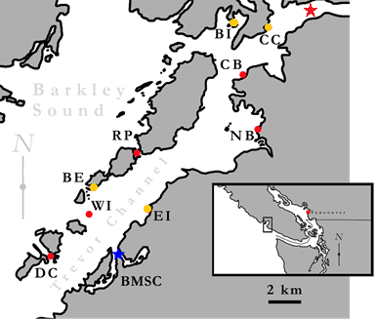

**Figure 2**: Log-transformed abundance, rarefied species richness, and Simpson’s diversity of seagrass epifaunal invertebrates (A1-A3) and the subset of epifaunal invertebrates that are grazers (G1-G3) across nine meadows in Trevor Channel, B.C. (see Figure 1). Meadows are arranged in the order of their distance from freshwater originating in Alberni Inlet.  Meadows were sampled in May (black), June-July (dark grey), and August (light grey) of 2012.

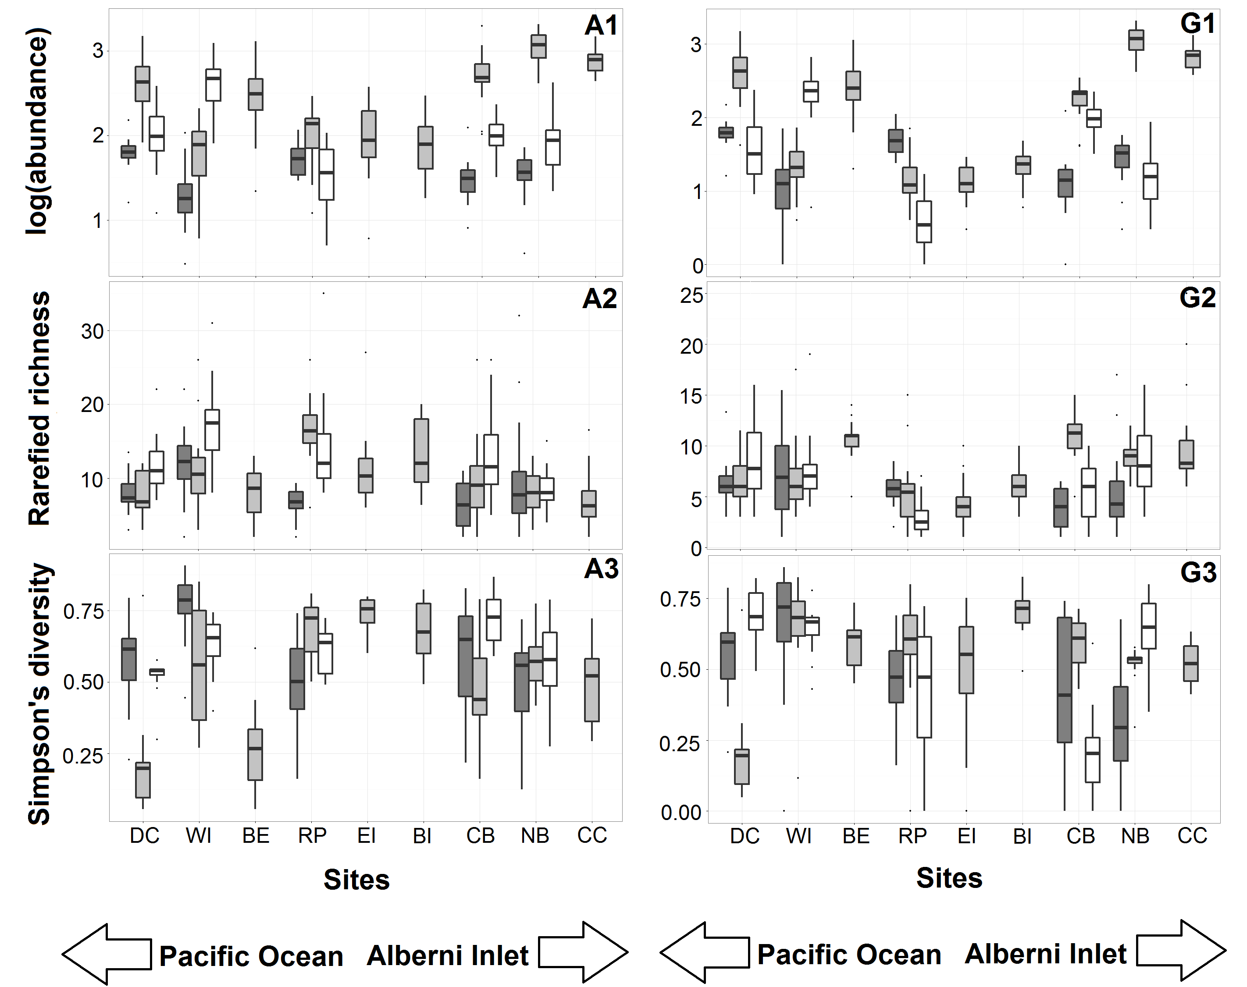

**Figure 3:** Dispersion of multivariate community for each site and sample period using the Bray-Curtis dissimilarity index (Appendix 4). Red filled points represent average median value observed in null model analyses.

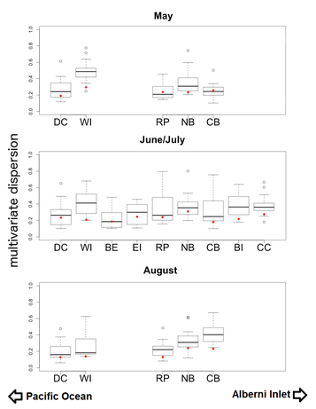

**Figure 4:** Nonmetric Multidimensional Scaling (NMDS) plot visualizing community composition across all sites and times. Polygons represent multivariate communities for each meadow at one time (n = 16 samples per meadow). Polygon area is representative of observed within-meadow beta diversity, such that a larger polygon indicates greater beta diversity among the plots sampled from that meadow. Overlap of polygons indicates similar species composition and relative abundance from plots sampled within different meadows. First two letters of polygon labels are the site codes, given in Table 1 and Figure 1, and the third letter indicates the time period sampled (A = May, C = July, and E = August).